GSOE9758 Network System Architecture

Final Report

Title: Business Model, Architecture, and Evaluation of K&S Corporation Limited Company

|  |
| --- |
| Group 5:  Siheng Liu(z5335939) Yimin Xu(z5300453) Pengrui Ma(z5249481)  Yiyan Yang(z5183946) |

**Abstract**

This report consists of three parts. In the first part, we employ business canvas model to analyze some characteristics of K&S corporation limited company. Besides, we discuss the vision, goal, and requirements (VGR) in terms of this company. In the second part, capabilities and required component has been offered and it helped develop the ambitious requirements. Then we provide the architecture structure to summarize the deployment of those advanced technical components vividly. Finally, we give some reflection based on our learning on this project.

**Keywords:** Business Canvas Model, VGR, Network Capabilities and Components, Architecture.

**1. Business Aspects**

**1.1 General Background**

Our company is Formed in 1945 through a partnership between Kain and Shelton that’s where our name K&S come from. In the Past 70 years, we have grown into one of Australia and New Zealand’s largest multi-modal providers.

Multimodal transport means that we distribute and deliver goods under a single contract, but with at least two different modes of transport. We provide road, rail and coastal sea forwarding in support of bulk loads and the delivery of integrated supply chain and we provide system solutions to our key customers.

We are also operating a comprehensive business matrix to cover different needs: K&S FREIGHTERS, KS Energy, Chemtrans for chemical, KS Bulk, DTM business logistics, heavy haulage and K&S Fuels.

We treat safety and innovation as our most important value, so we are also planning business revolution to adapt the situation of peri-covid era and to meet the requirement of increasing needs and higher standard. Besides the requirements of COVID safe delivery, we are also planning to adopt new technology to meet increasing needs in logistics. To maintain our high standard of safety and quality, we have set up detailed goals of internal upgrading.

1.2 Business Canvas Model

The business canvas model has usually been introduced as a promising solution to logically describe company organization, systemically analyze current strategy as well as offer the future blueprint of companies [1]. Specifically, the business canvas model consists of nine segments to facilitate a brief but comprehensive description of a company from a different perspective. Therefore, this report would introduce those nine segments based on K&S corporation limited company, respectively. The business canvas model was illustrated in Table 1.

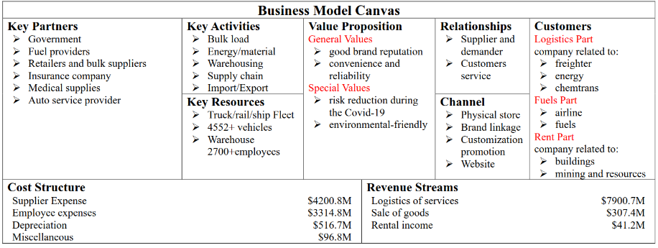Table 1 Business Canvas Model [2].

**Value Proposition**

The value proposition is the essential reason why customers turn to choose a company, the values proposition of K&S company is divided into two main categories.

(a) General Value Proposition

The first general value is good reputation, for example, K&S corporation limited company has been providing fuel and lubricant delivery services in Southeast Australia for nearly 60 years [3]. It is the only local fuel distribution in this region. Therefore, they hold a good brand reputation compared with other small companies which enables them to emerge as a promising and successful delivery company even under the negative influence of Covid-19. The second general value is convenience and reliability. For example, 24 hours services in the customer center are provided to satisfy any transportation orders. At the same time, the newest technologies, such as the modern fleet, are assigned with objections to reliable delivery [3].

(b) Special Value Proposition

Despite those general values, the development of this company highly depends on some special values. One is risk reduction during the Covid-19 pandemic, i.e., mandatory vaccination has been performed leading to zero employee Covid-19 cases. The stringent requirement in fighting Covid-19 provides a safety guarantee to customers. Besides, environmental-friendly logistics is another special value where this company exhibits lower energy consumption and carbon emission in their vehicles.

**Customer Segments**

According to the operation direction of this company, we categorize the consumers segments into three groups: logistics part, fuels part, and renting part. Firstly, logistic parts comprise the heart of revenue, which makes a significant contribution to their annual revenue. The common logistics customers include freighter companies, supermarkets such as Kmart, energy companies, and chemtrans companies [3]. For fuels parts, delivering fuels to some airline companies and the local drivers contribute to their secondary business. The third type of customer is about renting. They used to provide heavy cranes and related equipment to some building companies and mining companies.

**Revenue Streams**

In this company, the top three revenue includes logistics of services, which up to $583 million in 2021, sale of goods ($105 million), and an agency of some fuel sales ($120 million) [4]. Logistics businesses help this company survive well as its main revenue source. However, the logistics business declined significantly because of COVID-19, it is essential to imply some cost reduction policy to alleviate this situation.

**Channels**

In the past ten years, this company has focused on utilizing the physical store, brand linkage, and updating customization promotions to attract customers. However, with the development of technology, they evolve their offline channel into an online channel. Therefore, websites become a promising serving channel for future development.

**Customer Relationship**

K&S company presents a relationship as supplier and demander. Consumers offer their demands regarding logistics, fuels, or rent requirements, then these companies meet their requests. At the same time, this company also set increasing physical stores to provide the service and keep in contact with their consumers.

**Key Activities**

Our main business consists of bulk loading transport, delivery of energy and materials, warehousing, supply chain solution and logistics for import and export. We participate in a variety of market, some of them are manufacturers like Coca-Cola, some of them are demander of goods like Kmart, and we also offer service to material and chemical providers, energy companies. Of course, we have retail service for medium and small sized business. Besides the normal logistic business, we also lend our properties like warehouse and cars. To further increase the service quality, we are going to implant Big data analysis to our cloud center

**Key Resources**

Our Key resource is our transport fleet including more than Four Thousand Five Hundred vehicles and over seventeen hundred rail and sea containers. We also have 22 national depots and over one hundred and sixty thousand sqm of other state-based warehousing. Human resource is also critical to our business, we have two thousand seven hundred staff members with specialization in a broad range including: driving, auto mechanics, road planning, and architecture design.

Partners

Our long-term Strategic Partners include fuel providers, retailers and bulk suppliers. We have long-term and stable corporation with them, and we also have customized service for them like dedicated warehouse and trucks. We corporate with governments to build railway and acquire lands. They are often our key collaborator in the environment campaign. Service suppliers are also our long-term partner to ensure the safety and service quality. Such as Insurance company, medical supplies provider and Auto service provider.

**Cost Structure**

In terms of cost, as our main resources are human capital and transport fleet, the two major costs are Staff wages and supplier expense which are 4,000 million and 3,300 million respectively. Also, we are experiencing depreciation on physical assets each year. There are also some costs like financial costs and other costs, but they are much lower in numerical level.

**1.2 Aspirations, Objective, Strategies**

**1.2.1 Aspirations:**

To be leading provider of transport and logistics solutions within our target markets in Australia and New Zealand.

**1.2.2 Objective:**

1. **Safety**

Everybody Safe Every day. We care about each other’s health and wellbeing and will perform all tasks safely.

1. **Customer Service**

We will strive to meet and exceed the ongoing requirements of our customers.

1. **People & Community**

We empower, care, value, and respect our people, the relationships and communities we engage with.

1. **Innovation**

We are committed to creating solutions that add value and financial sustainability and security to shareholders and opportunity to our employees.

**1.2.3 Strategies**

1. **Safety**
2. The Group has enacted pandemic protocols to assist manage the safety of employees.
3. We have supported our employees who wish to access vaccinations through the provision of paid leave.
4. As with all safety incidents, the Group undertakes comprehensive investigations and will implement identified continuous improvement opportunities arising out of these accidents.
5. We continue to invest in our safety management system and in the training of our employees.
6. **Customer Service**
7. Chemtrans continues to develop and deploy a range of systems and procedures that will reinforce Chemtrans as the market leader in the transport of dangerous goods with regards to environmental and safety performance, while continuing to deliver efficiency benefits to its customer base.
8. We continue to align the operational and management structures to service the needs of business units and customers.
9. **People & Community**
10. A career at K&S offers more than a positive, healthy and stress-free work environment.
11. Maintaining our strong focus on the retention and development of skilled and qualified employees as the Group’s most valuable asset.
12. The Group will embark upon a major fleet upgrade in FY2022, adopting the latest Euro 6 emissions standards to further improve environmental performance.
13. **Innovation**
14. The Group has maintained its focus on operational efficiencies, supplier renegotiations, cessation of underperforming activities, and the rationalization and replacement of specific fleet assets that reduced operating costs.
15. Provide employees with diverse functions, flexible work arrangements, competitive compensation and vocational training.

**1.3 Vision, Goals, and Requirements**

**Vision**

Be the tier one Australasia logistics corporation in the development and provision of specialist logistics solutions.

**Goals**

Operating revenues return to pre-pandemic levels in 2022, increasing by 14.8%

The COVID-19 has had a devastating impact on the global tertiary sector. Due to this, our full year revenue declined by 12.9%. With the enactment of COVID policies and the support of government, the first goal is to increase our operating revenues back to pre-pandemic level, by 14.8%. We should try to broaden the sources of income and reduce expenditure, which includes the consolidation of departments, the enactment of pandemic countermeasure, the extension of our business scope and to secure our rail volumes, which is least affected by the Covid.

Keep on promoting Logistics 4.0 in the following 5 years

The second goal is to promote Logistic 4.0 through industrial upgrading. Logistic 4.0 is defined as using the data and analytics collected by smart manufacturing to improve operation efficiency and performance. And it’s a part of the fourth industrial revolution. The technologies we put into use will play a very important role in increasing productivity, and this is also what our corporation will focus on in the coming time.

Developing Green-logistics in the following 5 years, reduce emission load by 5% per year

Our last goal is to develop green logistics. Our commitment to the environment forms a key part of our corporate citizenship obligations and we are an industry leader in the field of reduced energy consumption and carbon emissions. In the following year we will still stick to environment.

**Requirements**

● Operating revenues return to pre-pandemic levels in 2022, increasing by 14.8%

- Department consolidation

- Enact pandemic countermeasure

- Extend business scope

- Secure parcels of rail volumes

● Keep on promoting Logistics 4.0 in the following 5 years

- Standardization and modularization of logistics industry

- Individuation and intellectualization of software and control system

- Digitization and automation based on intelligent sensors and products

- Digital Twin (AR, VR) to help product lifecycle management (PLM)

- Logistics optimization and decision support based on AI

- Human-machine Cooperation

● Developing Green-logistics in the following 5 years, reduce emission load by 5% per year

- Include eco-friendly criteria in your procurement policies

- Optimize transport fleet management

- Warehouse that follows sustainable construction and management standards

- Enable measures to reduce and recycle the waste produced

- Improve stock management and reverse logistics processes

**2. Architecture**

**2.1 The road to Network Capabilities and Related Components**

**Online System**

The first requirement is to establish an online transaction processing system. The online digital platform would attain numerous gains in canceling geometry barriers. On the one hand, business orders would not be limited by geometry location. On the other hand, cloud data stored in online system could be accessed from any sub-companies where accessible could financial records effectively avoid potential corruption. Cloud server, storage, IEEE 802.1 protocol, and computer hardware are significant components to construct this system.

**Advanced Traffic Management System**

The second requirement is to digitize management platform. K&S company needs to construct an advanced management system to provide environmental-friendly and efficient logistic services. Based on past location and routes data of vans and fleets, machine learning could compute the optimal delivery routes for each car and assign the suitable logistic tasks to each driver leading to lower fuel consumption. In addition, when each car offers instantaneous and accurate traffic information for the central management platform, this system can give accurate guidance and feedback to each car and then avoid some traffic congestion or terrible traffic accident. An advanced traffic management contains automatic vehicle location system (concluding GPS and RFID), electronic, sensors, wired and wireless communication devices, Cloud computing, machine learning, and WAVE Short Message Protocol.

Warehouse Management System

Wireless readers capture volume and dimensions, and send them to the WMS for processing, which provides real-time visibility into inventory levels. Stock levels are then updated automatically in the WMS for accurate inventory control. By combining sensors and WMS data with directional barcodes placed on the ceiling of the warehouse, we create an indoor GPS system, which can identify inefficiencies in AGV which include automatic guided cars, automatic pallet mover and transfer robot. Connected assets in a warehouse also enable predictive maintenance. By measuring the pressure and the temperature of the machine, the system can operate predictive maintenance analytics, schedule maintenance appointments and calculate the expected lifetime.

**2.2 Trade-offs**

**2.2.1 Data storage (Local VS Cloud)**

In recent years, with the rapid development of cloud technology, companies are considering putting corporate data in the cloud. Especially during the epidemic, it has become the norm for employees to work from home. With access to the same data and tools through cloud services, teams can coordinate their work more efficiently. Partnering with a cloud provider saves businesses from having to spend a lot of money and space to build their own storage servers. But companies must rely on them to stay safe. It is difficult for companies to ensure that their chosen cloud partners are not hacked.[6]

Therefore, under the trade-off, K&S will save important places, such as user data and company secrets, on its own servers, while the rest of the office data is stored in the cloud.

**2.2.2 Route plan (Fixed route VS Intelligent path planning)**

The second point is route planning. K&S employs a number of drivers in Australia and New Zealand, all of whom have familiar traffic routes. But sometimes companies find these routes inefficient due to special circumstances, such as road construction or traffic restrictions. If a company builds an intelligent route planning platform, its drivers can choose the right road based on the destination and the goods to be transported. When an accident occurs on the road, the driver can also receive the information in time to change the route, which will greatly improve the transportation efficiency of the company. But building and maintaining this platform requires a lot of investment.

After weighing their respective advantages and disadvantages, K&S decided to choose to develop intelligent path planning because the company's business is very large, and the benefits brought by efficiency improvement are far greater than the cost of maintaining the platform.

**2.2.3 Cargo sorting (Manual sorting VS Automatic sorting)**

In logistics, packages to different destinations need to be sorted. The company plans to introduce a smart sorting system, which will greatly reduce the possibility of errors and prevent employees from roughing up packages. However, the intelligent sorting system requires huge capital investment and space requirements in the early stage, which requires the company to carry out capital and site planning in advance. Manual sorting can be more flexible. Sites can employ varying numbers of workers to deal with production peaks and valleys.

Therefore, for sites with a large volume of transit packages, the company will choose to build an intelligent sorting platform. Manual sorting is still the best choice for stations with a small transfer volume.

**2.2.4 Warehouse monitoring (GPS VS Camera target tracking)**

GPS chips are used in the warehouse to record the flow of goods. Since GPS signals are ubiquitous, the system can monitor the location of goods without dead ends. But due to the lack of GPS accuracy, supervisors only know roughly where it is. Therefore, the company will consider another technology to solve this shortcoming, namely camera target tracking. Through cameras and artificial intelligence algorithms, objects are captured in real-time and uploaded to the cloud. Through the cooperation of multiple cameras, employees can clearly obtain the specific location of the goods. However, this requires companies to constantly update algorithms and cameras for a better experience.

So eventually business executives decided to install GPS chips on the outer packaging of large, difficult-to-move industrial products to cut costs and add multiple cameras to small shelf areas to ensure accurate object tracking.

**2.3 Architecture design**

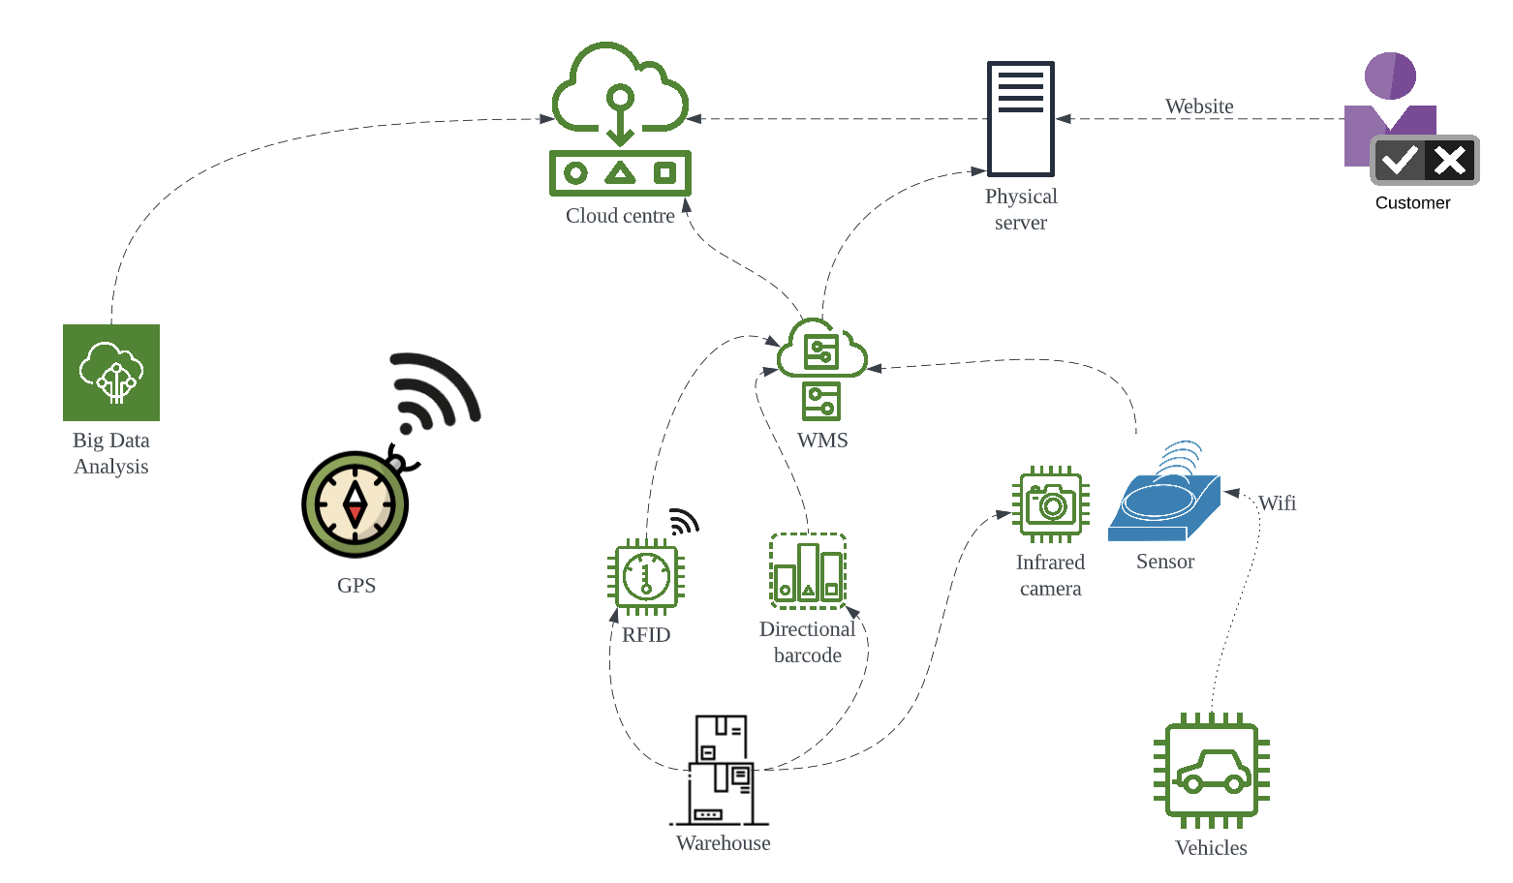

We divided the elements in our architecture into three parts: Soft assets, Computing resource and Information provider. The soft assets are website, big data analysis platform and the Ware house management system. And the computing resources are cloud centre and physical server. The remaining things are information provider, and they are the basic units of the IoT infrastructure.

Physically, there are two major scenarios: Warehouse and Vehicles, Typically stationary components with physical link are used in the warehouse. And for the vehicles, components with remote access are widely used. The GPS monitor is an optional component on each entity on demand, so it is placed separately on the diagram.

We put RFID and barcode on different entities according to the need. As we discussed before, we may put RFID on more valuable fragile goods and on indoor vehicles. And the directional barcode is used in more general products. Sensors and cameras are used both on vehicles and in warehouse. They can be used for safety reasons and they can also be used to monitor the status of the goods. For example, we use pressure sensors and infrared cameras for chemical containers.

**3. Reflection on the process**

**Siheng Liu:**

Numerous guest lectures were held through this course. Rather than preaching or telling obscure expertise, these professional industry insiders show us network architecture from a macro perspective. We no longer focus on a small switch or router, but see a magnificent network system hidden behind a school, a company or even a country. This is the thing that struck me the most about this course. In this project, we were asked to perform an architectural analysis and propose technical requirements and trade-offs of an enterprise as a practitioner. Collaboration is the most important lesson I have learned. The whole project is carried out in a group collaborative manner. My group members and I usually have discussions on Thursday, Saturday and Monday to confirm the tasks and division of labor for the next stage, share the collected information and confirm the task progress. In discussions, everyone's opinions cannot always be the same. We will state and express our views, listen to and think about others’ perspective, and reach consensus through communication and discussion.

**Yimin Xu:**

Every guest speaker in our lectures gives me a comprehensive knowledge of practical network cases based on their companies such as Cisco. Particularly, I was mostly inspired by the speaker in Week9, who holds a cross-disciplinary educational background in IT and telecommunication. It gives me the courage to attempt some future jobs related to programming with background in telecommunication. In addition, task organization, team discussion, and group presentation during our group project have strengthened my academic skills. As a result, both the course and project experiences enable me to understand how to rethink questions from a business perspective, cooperate with teammates, and extend my knowledge of networks.

**Pengrui Ma:**

I learned a lot when the courses and projects were completed. In this course, I learned how to study a company's financial report and analyze the company's business model. This made me realize that the application and development of technology need to be combined with the company's planning and user needs.

During the project research, I got to know three responsible teammates. We can only discuss through the Internet because of the epidemic. But every time we can divide the labor and complete the task well. However, due to the constraints of knowledge and time, it is difficult for us to analyze the company's business decisions in more depth. For the application of technology, our team just built the application framework in a superficial way and did not discuss the use of each component in depth. This is something I regret about the project.

**Yiyan Yang**

I was impressed by the format of teaching and course design. Different to the courses I’ve taken before that focus on the knowledge itself, this course introduce each knowledge point by real-life examples. This is quite an interesting experience for me to try to map the skill we learnt from school to real applications. The guest lecturers represents different segments in the market and all have different view of applying technologies. I learnt that in different level of market, the focal point of architecture design also varies. For low-level infrastructures, availability and stability is the most important goal. However, for commercial level projects, scalability and efficiency become more important. In addition to what we were taught from the lectures, I also learnt some practical skills in the group assignment.

Our group mates come from different faculty, so we have different knowledge and cognition to the concept: architecture. Different to the top-down approach usually used in computer science area, mates who major in tele-communication demonstrated how to solve problem from bottom to up. I found that I overlooked many approach to the problems, especially the technical detail and the interconnections between components. We also worked hard to resolve conflicts and corporate with each other. Fortunately, we finished the project thanks to the diversified skill set of our team.

1. **Conclusions**

In general, the first part of the report summarizes the company's business model and future company goals by analyzing K&S's financial report. In order to achieve the goals customized by the company, the second part combines the Internet of Things technology to build a technical framework. And trade-offs for data storage, route planning, parcel sorting, and item tracking are discussed, and a decision is made on the application of the technology.

**Reference**

[1] Business Model Canvas - Wikipedia. En.wikipedia.org. (2022). Retrieved 12 April 2022, from https://en.wikipedia.org/wiki/Business_Model_Canvas.

[2] Fauvel, C. (2013). Criticisms, variations, and experiences with business model canvas prof. Hong Y ching. European Journal of Agriculture and Forestry Research, 1(2), 26-37.

[3] K&S Corporation. Ksgroup.com.au. (2022). Retrieved 12 April 2022, from https://www.ksgroup.com.au/.

[4] Ksgroup.com.au. (2022). Retrieved 12 April 2022, from http://www.ksgroup.com.au/wp-content/uploads/documents/KSAnnRep18FINAL.pdf.

[5] Macaulay, J., Buckalew, L., & Chung, G. (2015). A collaborative report by DHL and Cisco on implications and use cases for the logistics industry. Internet Things Logist., Troisdorf, Germany, 1-27.

[6] Obrutsky, S. (2016). Cloud storage: Advantages, disadvantages and enterprise solutions for business. In Conference: EIT New Zealand.